**EXP NO 10**

**Create a data visualization (e.g., pie charts, bar graphs) for an inventory management system using javascript**

**Inventory Management System**

To visually represent stock levels in various inventory categories using **pie charts** and **bar graphs** created with **Chart.js** in JavaScript.

The project is made using **HTML & CSS** to create and style the web page layout , **JavaScript** to add logic for chart generation and **Chart.js** which is a library used to create interactive and responsive charts

**Step 1: Create the HTML Page**

We began by creating an HTML file (index.html) that contains:

1. A heading (<h1>) for the project title.
2. Two <canvas> elements – one for the **pie chart** and another for the **bar graph**.
3. A stylesheet inside the <style> tag to style the page.
4. Script links to **Chart.js** (for drawing the charts) and a custom **script.js** file where our chart code lives.

<!DOCTYPE html>

<html lang="en">

<head>

<meta charset="UTF-8">

<meta name="viewport" content="width=device-width, initial-scale=1.0">

<title>Inventory Management Visualization</title>

<style>

body {

font-family: Arial, sans-serif;

text-align: center;

margin: 50px;

}

canvas {

margin: 20px auto;

}

</style>

</head>

<body>

<h1>Inventory Management System</h1>

<canvas id="pieChart" width="400" height="400"></canvas>

<canvas id="barChart" width="400" height="400"></canvas>

<script src="https://cdn.jsdelivr.net/npm/chart.js"></script>

<script src="script.js"></script>

</body>

</html>

**Step 2: Write the Chart Code in JavaScript**

We then created a new file named script.js. Inside this:

1. We defined an inventory dataset with categories like Electronics, Clothing, Books, etc., and the number of items available in stock.
2. We used Chart.js to create:

A pie chart to show how the stock is distributed across categories.

A bar chart to show the count of items for each category.

1. We customized the charts using options such as titles and colour schemes.

javascript

script.js

// Data for the inventory

const inventoryData = {

labels: ['Electronics', 'Clothing', 'Home Appliances', 'Books', 'Toys'],

datasets: [

{

label: 'Items in Stock',

data: [200, 150, 100, 80, 50],

backgroundColor: [

'#FF6384',

'#36A2EB',

'#FFCE56',

'#4BC0C0',

//

'#9966FF'

],

}

]

};

// Creating the Pie Chart

const ctxPie = document.getElementById('pieChart').getContext('2d');

const pieChart = new Chart(ctxPie, {

type: 'pie',

data: inventoryData,

options: {

responsive: true,

title: {

display: true,

text: 'Inventory Distribution'

}

}

});

// Creating the Bar Chart

const ctxBar = document.getElementById('barChart').getContext('2d');

const barChart = new Chart(ctxBar, {

type: 'bar',

data: inventoryData,

options: {

responsive: true,

title: {

display: true,

text: 'Items in Stock by Category'

},

scales: {

yAxes: [{

ticks: {

beginAtZero: true

}

}]

}

}

});

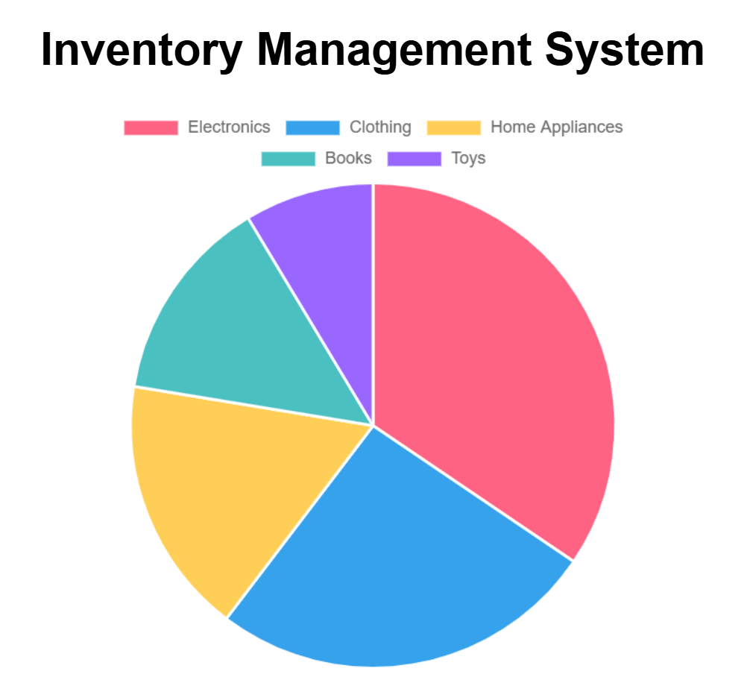

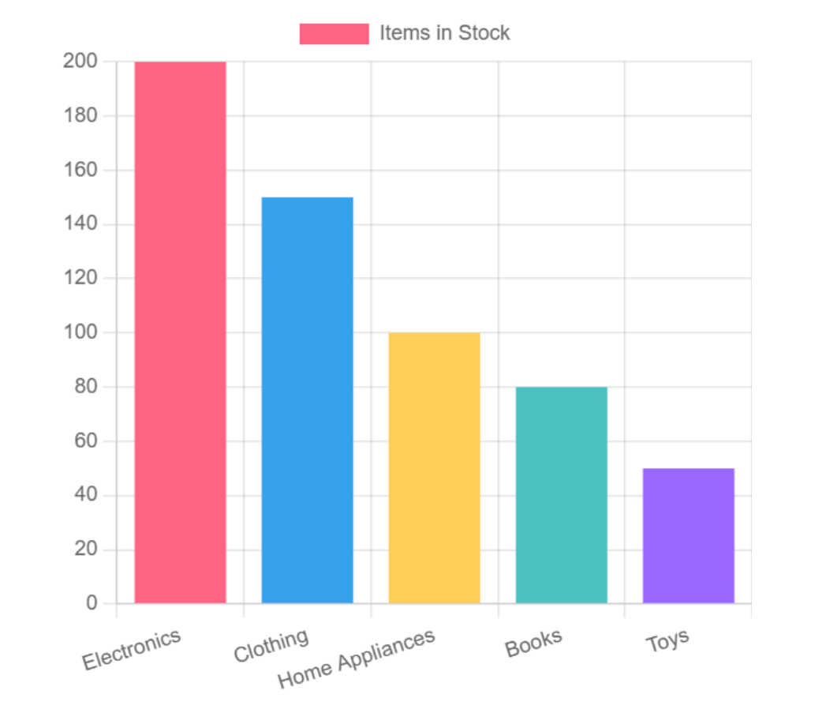

The **Pie Chart** gives a clear idea of which categories have the largest share in the inventory.

The **Bar Chart** displays the exact number of items in each category in a vertical format.

This project successfully demonstrates how to visualize inventory data using JavaScript and Chart.js through intuitive pie and bar charts. By representing stock levels across different product categories visually, it enhances data readability and decision-making efficiency for inventory managers. The simple integration of HTML, CSS, and JavaScript makes the solution lightweight, easy to maintain, and visually effective for real-time inventory tracking.